**APPLIED STATITICS LAB**

**WEEK-4**

NAME: SRIJITH U

REG NO : 22BCE8916

Mean

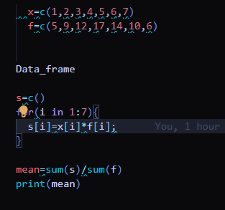

Output:

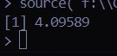

Median

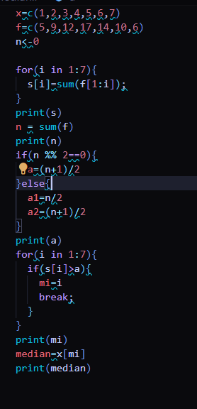

Output:

